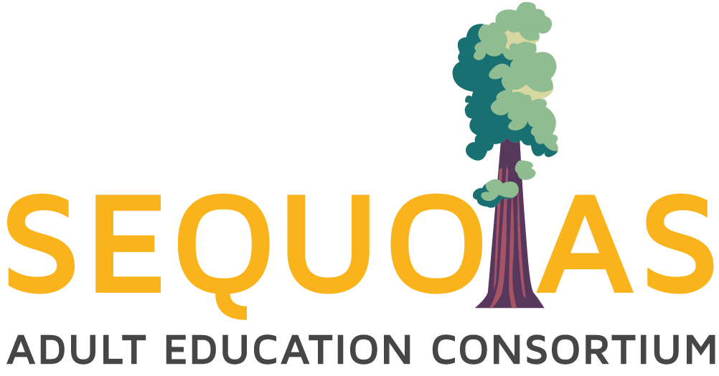

**SAEC Leadership Committee Meeting**

January 30, 2025, 3:00PM - 4:30pm

Zoom Meeting

Co-Chairs: Heather Keran and Jonna Schengel

Join Zoom Meeting

<https://us02web.zoom.us/j/85942071025?pwd=VNbR9NjDRtLlb32hj0miCZGEGpw77m.1>

Meeting ID: 859 4207 1025

Passcode: 608572

---

One tap mobile

+16699009128,,85942071025#,,,,*608572#

Agenda

* Opening Business
  + Call to Order
  + Welcome and Introductions
* Approval of Notes
  + [11.05.24 SAEC Leadership Committee Meeting Minutes.docx](https://docs.google.com/document/d/1yEx9yj6my5Amh10erTUploavPsJJ9hzm)
* Action Items:
  + None
* Information/Discussion Items (All supporting documents attached to this agenda in the order they appear on the agenda. Meeting participants will find a link to an electronic version of this agenda, which has active links to all supporting documents) here:
  + SAEC Attendance Accounting Policy, Practice, Protocol
    - [Standard Operating Procedure Guideline](https://docs.google.com/document/d/1xbgJJYoikk7AcESYISg5aO4mUdSUzvzHyXIdgqG6fd0/edit?tab=t.0)
  + Governance
    - SAEC 2025-28 MOU
      * [SAEC Amended “FINAL COLA” MOU 2024-27](https://docs.google.com/document/d/1TO5ZPMuSKDcfOXjGJ5FKXCsVOKRCEN39/edit)
    - SAEC Report on Consortium Governance 2025.26
      * [SAEC Report on Consortium Governance 2024.25](https://docs.google.com/document/d/1-M2Qg-xNTUxyRSxMHPXE-sFCwXmuPm1Q/edit?usp=drive_link&ouid=114736191070370070679&rtpof=true&sd=true)
    - SAEC CFAD 2025.26
      * Due 5.2.25
      * 2024.25 CFAD Located in NOVA
  + Deliverables and Updates- John Werner
    - WIOA Title II
      * Signed Q3 GAN Amendment - uploaded and mailed - 02/28/25
      * Second Quarter Expenditure Claim Report - 01/31/25

* + - **CAEP** 
      * **January 2025**
        + Jan 31: Student Data due in TOPSPro (Q2)
        + Jan 31: Employment and Earnings Follow-up Survey
      * **February 2025**
        + Feb 28: Preliminary allocations for 2025-26 and 2026-27 released by this date.
      * **March 2025**
        + Mar 1: 22/23 and 23/24 and 24/25 Member expense report is due in NOVA. (Q2)*
        + Mar 31: End of Q3
        + Mar 31: 22/23 and 23/24 and 24/25 Member Expense Report certified by Consortia in NOVA (Q2) *
      * **April 2025**
        + Apr 30: Student Data due in TOPSPro (Q3)
        + Apr 30: Employment and Earnings Follow-up Survey
      * **May 2025**
        + May 2: CFAD for 2025-26 due in NOVA *

* + Spring 2025 Site Visits

* + Updates on PD Calendar

* + RISDS (reminder)
    - Upcoming Navigator Events
      * Social Media & Canva Bootcamp
        + Becerra and Jones - January 15, 22, 29 & Feb 5 (3 hours per day)
        + Delgado and Lopez - TBD
      * TKCCC 8th Annual Counselor Conference January 29, 2025
        + Delgado and Lopez
      * COAS Orientations (every other Wednesday) February 5, 2025
        + Lopez
      * LAS Adult Ed Celebration Fair February 6, 2025
        + Lopez
      * World Ag Expo February 11- 13, 2025
        + All Navigators
      * CVIIC Annual Regional Conference on Immigrant Integration February 25, 2025
        + All Navigators and SAEC Office
      * Growing Health Leaders Conference March 20, 2025
        + All Navigators
      * Industry Sector Summit - Transportation April 1, 2025
        + All Navigators
      * TCOE Support Staff Conference April 22, 2025
        + Delgado and Lopez
      * Sequoia High School CTE Presentation April 22, 2025
        + Becerra
      * VAS Adult Education Celebration April 23, 2025
        + Becerra
      * TAS Adult Education Celebration April 29, 2025
        + Delgado
      * CCAE State Conference May 1-3, 2025
        + In Fresno
        + All Navigators and SAEC Office
  + Professional Development
    - * CAEP Consortium Management Series
        + <https://register.caladulted.org/>
      * Advancing Adult Education Website
        + <https://caladulted.org/Practice>
      * [CIP: Q&A with Dr. Zachary](https://scoe.zoom.us/j/81940379346?pwd=pbgUZh4wrZ7a00OCdfg2brhenqZaGs.1) - Register via OTAN
        + Feb 12 - 1:00 PM
        + **Meeting ID**: 819 4037 9346
        + **Passcode**: 54010
      * 2025 COABE - Adult Education: Expanding Horizons
        + Dallas, TX, March 30 - April 2, 2025
        + Indianapolis Indiana - 2026
      * CCAE State Conference
        + Fresno, California, May 1 - 3 , 2025
        + [Registration](https://ccaestateconference.regfox.com/ccae-2025-state-conference)

**Reminders:**

* + Member Effectiveness Report Schedule:

* + - Schedule for 2024-2025
      * ~~October 2024 - SAEC Report and NIF Report by Navigators~~
      * [~~November 2024~~](https://docs.google.com/presentation/d/1mZ6wLog08ri9UA-UWDE883yUo0Vasftv/edit#slide=id.g3092b824c74_0_296) ~~- Hanford Adult, Visalia Adult~~
      * [February 2025](https://docs.google.com/presentation/d/1Qhq8DxFlwT4aNem8uUpteju_r-tGIdGJ/edit#slide=id.g2b6eff2fb46_0_421) - Corcoran Adult, Lindsay Adult
      * [April 2025](https://docs.google.com/presentation/d/1grFmU4jqLchL0iyjxXuAKg39yTt1u80Z/edit#slide=id.g21a8f94e41d_0_0) - College of the Sequoias, Cutler-Orosi, Farmersville. Tulare Adult School
  + Program Area Committee meeting dates (SAEC PD Calendar Event invites sent out. Agendas pending)

* + - Meetings will be in person.

* + - ESL - **Tulare Adult School**
      * ~~September 27, 2024 1:30 - 3:00PM Friday~~
      * April 4, 2025 1:30 - 3:00PM Friday

* + - ABE/ASE - **Hanford Adult School**
      * ~~September 9, 2024 1:30 – 3:00PM Monday~~
      * April 7, 2025 1:30 – 3:00PM Monday
    - AWD - **Visalia Adult School**
      * ~~September 20, 2024 1:30 – 3:00PM Friday~~
      * April 25, 2025 1:30 – 3:00PM Friday
  + SAEC Data Community of Practice meeting dates:
    - [Participant List (please update)](https://docs.google.com/spreadsheets/d/1shjvJmYrq2S6r_UoTqE8q2hVupIAp5VV/edit?usp=sharing&ouid=114736191070370070679&rtpof=true&sd=true)
    - [SAEC Data COP Google Drive Main Folder](https://drive.google.com/drive/folders/1JSXt1pOgzEKPkHu38N1bylGT8QmF62I3?usp=sharing)
    - [SAEC Data COP Google Drive 2024.25 Folder](https://drive.google.com/drive/folders/1TmEUM60qL10S-3Kx4GqLS7X7hIA2AjDa?usp=sharing)
    - 2024.25 Meeting Dates:
      * [~~Q1 10.17.24 @ 11:00AM~~](https://drive.google.com/drive/folders/1whBsFu1bc3IjSjZP3oG-HjZYKuqd5UbO?usp=drive_link)
      * [Q2 01.17.25 @ 11:00AM](https://drive.google.com/drive/folders/1cAkVTGb5AyTBcx_wt3T5Cft7uav1mboR?usp=sharing)
      * [Q3 04.11.25 @ 11:00AM](https://drive.google.com/drive/folders/1NhPEZdjg_CjoMmJIc48EEqE5FFAWGXjG?usp=sharing)
      * [Q4 06.27.25 @ 11:00AM (option 1)](https://drive.google.com/drive/folders/17JSvrwgsC_CJf0MnRR2SCqN-yeV3njEH?usp=sharing)

[07.03.25 @ 11:00AM (option 2)](https://drive.google.com/drive/folders/17JSvrwgsC_CJf0MnRR2SCqN-yeV3njEH?usp=sharing)

* Both need to be moved to a Thursday
  + Next Leadership Committee Meeting Agenda - Heather Keran
    - Meeting: 2/04/25 after Board Meeting
    - COS, Sequoias Room 1

* + Next [SAEC Board Meeting Agenda](https://docs.google.com/document/d/1ucvDioXONI5ongTr7iwzGyytgRqSL1w9/edit?usp=drive_link&ouid=114736191070370070679&rtpof=true&sd=true) - John Werner
    - Meeting: 2/04/25 @ 8:00-9:30AM
    - COS, Sequoias Room 1
* Adjournment