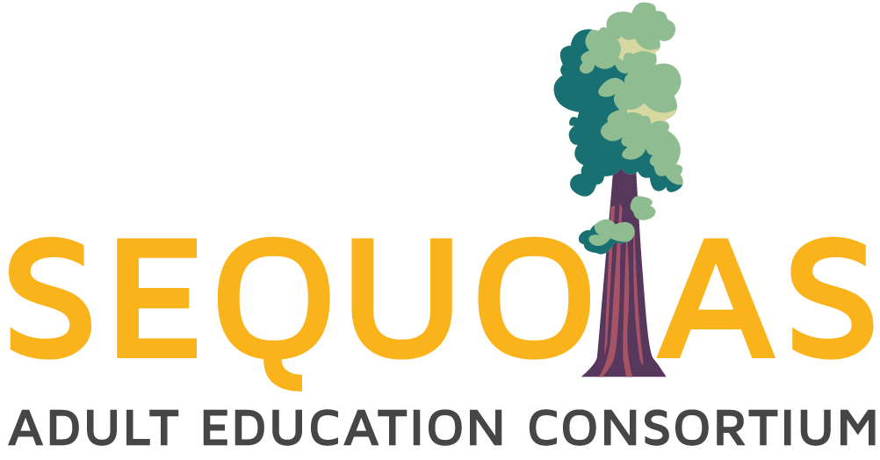

**SAEC Leadership Committee Meeting**

November 5, 2024, 9:45-11:45AM

COS, Sequoias Room 1

Co-Chairs: Heather Keran and Jonna Schengel

Agenda

* Opening Business
  + Call to Order
  + Welcome and Introductions
* Approval of Notes
  + [10.24.24 SAEC Leadership Committee Meeting Notes](https://docs.google.com/document/d/17vY6ioSgo76J4JJoaYKfcYi9zNWEe6SI/edit)
* Action Items:
  + None
* Information/Discussion Items (All supporting documents attached to this agenda in the order they appear on the agenda. Meeting participants will find a link to an electronic version of this agenda, which has active links to all supporting documents) here:
  + 2024-2025 Budget Development Retreat
    - March 2025
  + ESL Alignment - Jonna Schengel
    - Continue discussion from last meeting
  + HSD Graduation Requirements Member Progress Update - All
    - Existing member board policy review
  + [SAEC Attendance Accounting Policy, Practice, Protocol](https://docs.google.com/document/d/1JIz9xHqHBWJAjlfc_HOPL5aiDkd9ZqZNYUrBixu2Au4/edit?tab=t.0) - Amalia
    - Competency-based attendance hour accrual (non-seat time and not asynchronous)
  + 2024/25 Allocation Amendment
  + 2024/25 Governance Docs - Please return to SAEC Office - LaDonna [Ljones01@vusd.org](mailto:Ljones01@vusd.org)
    - Member Document Status
      * Complete:
        + College of the Sequoias
        + Cutler-Orosi
        + Exeter
        + Hanford
        + Tulare
        + Visalia
        + Woodlake
      * Incomplete:
        + Alpaugh
        + Corcoran
        + Farmersville (In Process)
        + Lindsay
    - [Amended 2024-27 SAEC MOU](https://docs.google.com/document/d/1TO5ZPMuSKDcfOXjGJ5FKXCsVOKRCEN39/edit?usp=drive_web&ouid=114736191070370070679&rtpof=true)
      * This goes to LEA boards
    - [SAEC Report on Consortium Governance 2024/25](https://docs.google.com/document/d/1-M2Qg-xNTUxyRSxMHPXE-sFCwXmuPm1Q/edit)
      * This goes to LEA boards
    - 2024/25 Allocation Amendment
      * [CAEP FY24-25 Final Allocations Schedule * (072524)](https://caladulted.org/DownloadFile/1356)
      * [CAEP TY24-25 Final Allocation MEMO](https://caladulted.org/DownloadFile/1355)
      * [CAEP FY24-25 Final Allocations Schedule_r](https://caladulted.org/DownloadFile/1354)
      * [CAEP -- Preliminary Allocations Memo FY 2024-25](https://caladulted.org/DownloadFile/1339)
      * [FY 2024-25 CAEP Preliminary Allocations Schedule](https://caladulted.org/DownloadFile/1338)
  + [SAEC Annual Plan 2024.25](https://drive.google.com/file/d/1wBWy15NGqaAQ3t4GX5TSlIJLi6mKkude/view?usp=drive_link) - John Werner
    - MUST BE CERTIFIED BY 10/30/24
    - [CAEP Fact Sheet](https://caladulted.org/CaepFactSheets)
    - [Member Workplans and Budgets](https://docs.google.com/spreadsheets/d/179RJk2GHUpOfvuinBO1l2JuPedwKNcaW/edit?gid=900609495#gid=900609495)
    - In NOVA

* + Deliverables and Updates- John Werner
    - WIOA Title II
      * End of 23/24 processes status check by site
      * Grant Award Notification Letters and Budgets due.
        + GANs released 8/2/24
        + Signed as a virtual copy and uploaded; wet signature version mailed in to state
      * FPM
        + Three-year cycle
        + [Adult Education Instrument](https://drive.google.com/file/d/1ZbVHdG7Ac9VnJexgcFUGMWG0KIOHLqdY/view?usp=sharing)

* + - CAEP **(BOLD MEANS YOU ARE RESPONSIBLE FOR IT)**

**October 2024**

* + - * Oct 30: 24/25 Member Program Year Budget and Work Plan certified by Consortia in NOVA *
      * **Oct 31: Student data due in TOPSPro (Q1)**
      * **Oct 31: Employment and Earnings Follow-up Survey (Do not wait until the last minute on this one…it is a process, plan ahead.)**

**December 2024**

* + - * **Dec 1: July 1, 2023 to June 30, 2024 Instructional Hours and Expenses by Program Area due (actuals) in NOVA** and certified by Consortium *
        + In TE: Reports>State>California>CAEP Program Hours
      * **Dec 1: 22/23, 23/24 & 24/25 Member Expense Report Due in NOVA (Q1)**
      * Dec 31: 22/23, 23/24 & 24/25 Member Expense Report certified by Consortia in NOVA (Q1)
      * Dec 31: End of Q2

* + RISDS (Reminders)
    - Upcoming Navigator Events
      * ~~Tulare County Job Fair October 2, 2024~~
      * ~~South Valley Industrial Summit October 4, 2024~~
      * ~~Finding True North - Role of the Navigator October 8, 2024~~
      * ~~Innovators by Design October 9, 2024~~
      * ~~TAS College Fair October 16, 2024~~
      * ~~TCOE Special Services Resource Fair October 23, 2024~~
      * ~~CCAE Central Section Winter Conference October 25, 2024~~
      * ~~Farm Worker Conference October 31, 2024~~
      * Health, Sciences & Medical Summit November 7, 2024
      * Hanford Career Connections November 14, 2024
      * Healthcare Sector Summit December 5, 2024
      * Manufacturing & Industrial Summit December 10, 2024
      * College & Career Counselor Conference January 29, 2025
      * Building and Construction Summit January 30, 2025
      * Transportation Summit April 1, 2025
  + Professional Development
    - * CAEP Consortium Management Series
        + [https://register.caladulted.org](https://register.caladulted.org/)
      * Advancing Adult Education Website
        + <https://caladulted.org/Practice>
      * WIOA II from Portia LaFerla, [plaferla@casas.org](mailto:plaferla@casas.org)
        + Upcoming meetings w/links

**Reminders:**

* + Member Effectiveness Report Schedule:

* + - Schedule for 2024-2025
      * ~~October 2024 - SAEC Report and NIF Report by Navigators~~
      * [November 2024](https://docs.google.com/presentation/d/1mZ6wLog08ri9UA-UWDE883yUo0Vasftv/edit#slide=id.g3092b824c74_0_296) - Hanford Adult, Visalia Adult
      * [February 2025](https://docs.google.com/presentation/d/1Qhq8DxFlwT4aNem8uUpteju_r-tGIdGJ/edit#slide=id.g2b6eff2fb46_0_421) - Corcoran Adult, Lindsay Adult, Tulare Adult
      * [April 2025](https://docs.google.com/presentation/d/1grFmU4jqLchL0iyjxXuAKg39yTt1u80Z/edit#slide=id.g21a8f94e41d_0_0) - College of the Sequoias, Cutler-Orosi, Farmersville
  + Program Area Committee meeting dates (SAEC PD Calendar Event invites sent out. Agendas pending)

* + - Meetings will be in person.
      * **Proposed meeting location updates**

* + - ESL - **Tulare Adult School**
      * ~~September 27, 2024 1:30 - 3:00PM Friday~~
      * April 4, 2025 1:30 - 3:00PM Friday

* + - ABE/ASE - **Hanford Adult School**
      * ~~September 9, 2024 1:30 – 3:00PM Monday~~
      * April 7, 2025 1:30 – 3:00PM Monday
    - AWD - **Visalia Adult School**
      * ~~September 20, 2024 1:30 – 3:00PM Friday~~
      * April 18, 2024 1:30 – 3:00PM Friday
      * [Contact List](https://docs.google.com/spreadsheets/d/1qVo3OSm-D4A9jbx0LkwMH1IKpFSUG64KkIsGH2sbJ6Y/edit?gid=0#gid=0)
  + SAEC Data Community of Practice meeting dates:
    - [Participant List (please update)](https://docs.google.com/spreadsheets/d/1shjvJmYrq2S6r_UoTqE8q2hVupIAp5VV/edit?usp=sharing&ouid=114736191070370070679&rtpof=true&sd=true)
    - [SAEC Data COP Google Drive Main Folder](https://drive.google.com/drive/folders/1JSXt1pOgzEKPkHu38N1bylGT8QmF62I3?usp=sharing)
    - [SAEC Data COP Google Drive 2024.25 Folder](https://drive.google.com/drive/folders/1TmEUM60qL10S-3Kx4GqLS7X7hIA2AjDa?usp=sharing)
    - 2024.25 Meeting Dates:
      * [Q1 10.17.24 @ 11:00AM](https://drive.google.com/drive/folders/1whBsFu1bc3IjSjZP3oG-HjZYKuqd5UbO?usp=drive_link)
      * [Q2 01.17.25 @ 11:00AM](https://drive.google.com/drive/folders/1cAkVTGb5AyTBcx_wt3T5Cft7uav1mboR?usp=sharing)
      * [Q3 04.18.25 @ 11:00AM](https://drive.google.com/drive/folders/1NhPEZdjg_CjoMmJIc48EEqE5FFAWGXjG?usp=sharing)
      * [Q4 06.27.25 @ 11:00AM (option 1)](https://drive.google.com/drive/folders/17JSvrwgsC_CJf0MnRR2SCqN-yeV3njEH?usp=sharing)

[07.03.25 @ 11:00AM (option 2)](https://drive.google.com/drive/folders/17JSvrwgsC_CJf0MnRR2SCqN-yeV3njEH?usp=sharing)

* + Next Leadership Committee Meeting Agenda - Heather Keran
    - Meeting: 11/21/24 @ 3:00-4:30PM
    - Zoom Meeting

* + Next SAEC Board Meeting Agenda - John Werner
    - Meeting: 2/04/25 @ 8:00-9:30AM
    - COS, Sequoias Room 1
* Adjournment